Homework 6_Semester 2

Anna Moeller

3/21/2019

# Additional Problems

## Problem 1

n <- c(10, 50, 500)  
sumX <- c(6.1, 27.3, 262.4)  
  
# Bayesian CRI  
LCRI <- qgamma(0.025, n+5, 1+sumX)  
UCRI <- qgamma(0.975, n+5, 1+sumX)  
  
# Frequentist CI  
c1 <- qgamma(.975, n, 1)  
c2 <- qgamma(.025, n, 1)  
LCI <- c2/sumX  
UCI <- c1/sumX  
  
# Compare them  
t <- as.data.frame(rbind(LCRI, UCRI, LCI, UCI))  
names(t) <- n  
t

## 10 50 500  
## LCRI 1.1824488 1.464082 1.753644  
## UCRI 3.3083973 2.489692 2.088019  
## LCI 0.7861293 1.359376 1.742106  
## UCI 2.8007875 2.372916 2.076088

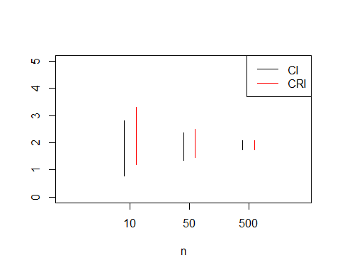

## Problem 3

### Part h

n <- 1:20  
theta <- 1  
  
# Expressions for MSE  
# Theta^  
theta_hat_MSE <- 2*theta^2/(n+1)/(n+2)  
# Theta^U  
theta_hat_U_MSE <- theta^2/n/(n+2)  
# Theta~  
theta_tilde_MSE <- theta^2/3/n  
  
# Plot the MSEs  
plot(n, theta_hat_MSE, type = "l", lty = 1, ylab = "MSE")  
lines(n, theta_hat_U_MSE, type = "l", lty = 2)  
lines(n, theta_tilde_MSE, type = "l", lty = 3)  
legend("topright", legend = c("theta_hat", "theta_hat_U", "theta_tilde"), lty = c(1,2,3))

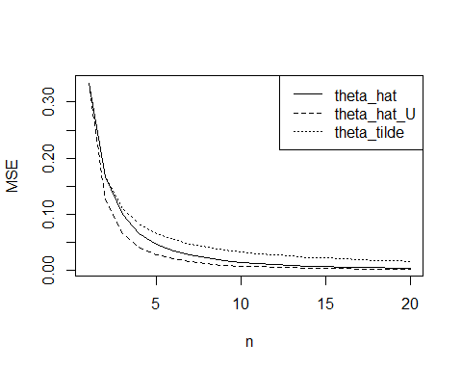

### Part i

theta <- 1  
n <- c(5, 10, 20)  
nsim <- 1e6  
   
theta_hat <- theta_hat_U <- theta_tilde <- matrix(NA, nrow = length(n), ncol = nsim)  
for(i in 1:length(n)){  
 for(j in 1:nsim){  
 X <- runif(n[i], 0, theta)  
 theta_hat[i, j] <- max(X)  
 theta_hat_U[i, j] <- max(X) * (n[i]+1)/n[i]  
 theta_tilde[i, j] <- mean(X) * 2   
 }  
}  
  
# calculate MSE from the sample  
sampMSE <- function(estimator, truth){  
 mean((estimator-truth)^2)  
}  
  
# Theta hat  
theta_hat_true_MSE <- 2*theta^2/(n+1)/(n+2) # true  
theta_hat_samp_MSE <- apply(theta_hat, 1, sampMSE, theta) # from sample  
  
# Theta hat unbiased  
theta_hat_U_true_MSE <- theta^2/n/(n+2)  
theta_hat_U_samp_MSE <- apply(theta_hat_U, 1, sampMSE, theta)  
  
# Theta tilde  
theta_tilde_true_MSE <- theta^2/3/n  
theta_tilde_samp_MSE <- apply(theta_tilde, 1, sampMSE, theta)  
  
t <- as.data.frame(  
 rbind(theta_hat_true_MSE,   
 theta_hat_samp_MSE,   
 theta_hat_U_true_MSE,  
 theta_hat_U_samp_MSE,  
 theta_tilde_true_MSE,  
 theta_tilde_samp_MSE  
 )  
)  
names(t) <- n  
t

## 5 10 20  
## theta_hat_true_MSE 0.04761905 0.015151515 0.004329004  
## theta_hat_samp_MSE 0.04755381 0.015194751 0.004338271  
## theta_hat_U_true_MSE 0.02857143 0.008333333 0.002272727  
## theta_hat_U_samp_MSE 0.02861634 0.008358694 0.002279727  
## theta_tilde_true_MSE 0.06666667 0.033333333 0.016666667  
## theta_tilde_samp_MSE 0.06668104 0.033321695 0.016697961